Experiment No 3
LAB MANUAL
PART B

Roll No. C-60 | Name: Avdhut Parish Madhavi
Class: SE-C | Batch: C2
Date of Experiment: | Date of Submission:
Grade:
B.1: Implement and trace the following programs. Write the code, compile/run it, and record the output after each task.
- Compare the number of comparisons made by the Divide and Conquer Min-Max program against a simple linear scan that tracks min and max in a single pass, for the same array.
CODE:
#include <stdio.h>
#include <conio.h>
int dcCount = 0;
struct Pair
{ int min;
int max;
};
struct Pair maxMin(int arr[], int low, int high)
{
struct Pair result, left, right;
int mid;
if (low == high)
{
result.min = arr[low];
result.max = arr[low];
return result;
}
if (high == low + 1)
{
dcCount++;
if (arr[low] < arr[high])
{
result.min = arr[low];
result.max = arr[high];
}
else
{
result.min = arr[high];
result.max = arr[low];
}
return result;
}

mid = (low + high) / 2;
left = maxMin(arr, low, mid);
right = maxMin(arr, mid + 1, high);
dcCount++;
result.min = (left.min < right.min) ?
left.min : right.min;
dcCount++;
result.max = (left.max > right.max) ?
left.max : right.max;
return result;
}
int main()
{
int arr[6] = {8, 3, 5, 1, 9, 2};
int n = 6;
int i, min, max;
int linearCount = 0;
struct Pair result;
clrscr();
result = maxMin(arr, 0, n - 1);
printf("Divide and Conquer Min-Max\n");
printf("Minimum = %d\n", result.min);
printf("Maximum = %d\n", result.max);
printf("Comparisons = %d\n\n", dcCount);
min = arr[0];
max = arr[0];

for (i = 1; i < n; i++)
{
linearCount++;
if (arr[i] < min)
min = arr[i];
linearCount++;
if (arr[i] > max)
max = arr[i];
}
printf("Linear Scan Min-Max\n");
printf("Minimum = %d\n", min);
printf("Maximum = %d\n", max);
printf("Comparisons = %d\n", linearCount);
getch();
return 0; }

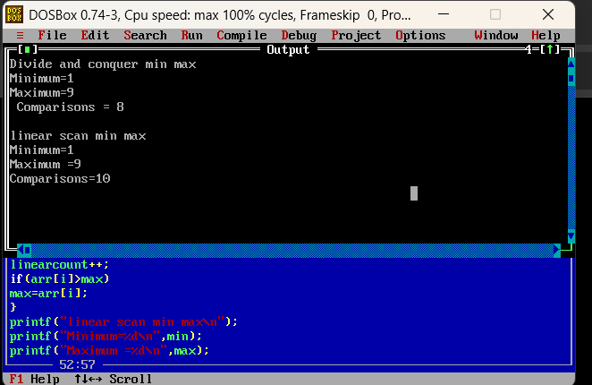

- Modify the Quick Sort program to choose the first element as the pivot instead of the last, and compare its performance with the original on the same reverse-sorted array.
CODE:
#include <stdio.h>
#include <conio.h>
int lastCount = 0;
int firstCount = 0;
void swap(int *a, int *b)
{
int temp;
temp = *a;
*a = *b;
*b = temp;
}
int partitionLast(int arr[], int low, int high)
{
int pivot, i, j;
pivot = arr[high];
i = low - 1;
for (j = low; j < high; j++)
{
lastCount++;
if (arr[j] <= pivot)
{
i++;
swap(&arr[i], &arr[j]);
}
}
swap(&arr[i + 1], &arr[high]);
return i + 1;
}
void quickSortLast(int arr[], int low, int high)
{
int pi;
if (low < high)
{
pi = partitionLast(arr, low, high);
quickSortLast(arr, low, pi - 1);
quickSortLast(arr, pi + 1, high);
}
}
int partitionFirst(int arr[], int low, int high)
{
int pivot, i, j;
swap(&arr[low], &arr[high]);
pivot = arr[high];
i = low - 1;
for (j = low; j < high; j++)
{
firstCount++;
if (arr[j] <= pivot)
{
i++;
swap(&arr[i], &arr[j]);
}
}
swap(&arr[i + 1], &arr[high]);
return i + 1;
}

void quickSortFirst(int arr[], int low, int high)
{
int pi;
if (low < high)
{
pi = partitionFirst(arr, low, high);
quickSortFirst(arr, low, pi - 1);
quickSortFirst(arr, pi + 1, high);
}
}
void main()
{
int a[8] = {8, 7, 6, 5, 4, 3, 2, 1};
int b[8] = {8, 7, 6, 5, 4, 3, 2, 1};
int i;
clrscr();
quickSortLast(a, 0, 7);
quickSortFirst(b, 0, 7);
printf("Original Quick Sort (Last Pivot)\n");
printf("Sorted array: ");
for (i = 0; i < 8; i++)
printf("%d ", a[i]);
printf("\nComparisons = %d\n\n", lastCount);
printf("Modified Quick Sort (First Pivot)\n");
printf("Sorted array: ");
for (i = 0; i < 8; i++)
printf("%d ", b[i]);
printf("\nComparisons = %d", firstCount);
getch();
}

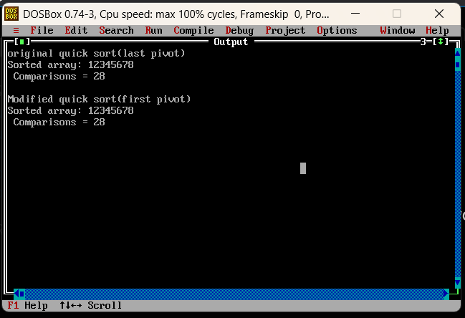

B.2: Write an observation according to the program execution.
Both programs sort the reverse-sorted array correctly. Both perform 28 comparisons because each pivot creates highly unbalanced partitions. Therefore, both have worst-case time complexity of (O(n2)) for this input.

